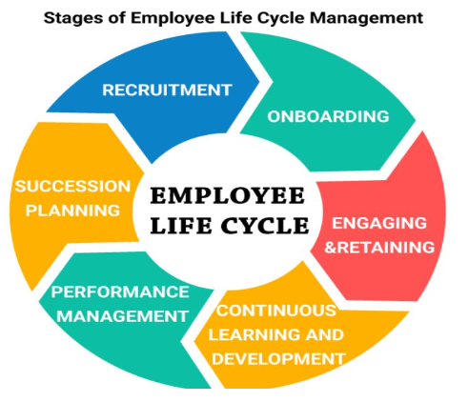
RECRUITMENT: “Hiring the Right people in the Right positions”
Internal process:
- Review share drive folders
  - PH recruiting process via Pachex Recruiting/Onboarding platform
  - Review job descriptions
  - Collect all open positions within assigned facilities
    - Interviewing Training – Maria
    - Prioritize job openings
    - Conduct phone screenings (Maria trains)
    - Provide finalist to supervisors for face-to-face interview
      - Meet with hiring managers
        - Recruiting process: how is it going?
        - Shadow supervisor’s face-to-face interviews
          - Provide feedback and aligned on selected candidate(s)
  - Review Job Offer request process via KissFlow
  - Review New Hire Orientation via Kissflow
  - HR sends job offer via DocHub – Maria trains
ONBOARDING: “A boot camp for new employees that help integrate into the new work environment faster”
- Onboarding Program based on role:
  - 90-day onboarding including goals per position
    - Specific steps per role
    - On-the-job-training
    - Leadership trainings
  - 180-day onboarding salaried level role
    - 1-2 full years to reach level of productivity
- Training Matrix:
  - Safety Training
  - Sexual Harassment
  - All other employee key trainings per Paychex offerings
  - Management Training:
    - Leadership trainings
    - HR Supervisor trainings, including employee protected laws and rights
    - Internal HR Trainings:
      - Onboarding
      - Corrective Action process: Attendance / Performance: Behavior
      - Leaves of Absences
      - Employee Development: frequent 1:1s
      - Termination processes
      - Employee Investigations

ENGAGING & RETAINING: “Building a Culture of Recognition”
- Build employee engagement:
  - Stay Interviews:
    - Acted upon feedback: regardless of yes or no
  - Employee Engagement Survey: Understand how engaged are our employees?
    - Collaborative Action Plans based on results
  - Recognition Programs:
    - On-the-spot recognition at least once a month
      - Point-base reward system:
        - Employees accumulates / redeems for rewards
    - Message of appreciation, at least one a day per leader
    - Employee of the Month per facility nomination
    - Employee Incentives:
      - Bonuses – On the Spot, Attained Goals
      - Gym memberships (?)
      - Extra paid time off
CONTINUOUS LEARNING AND DEVELOPMENT: “Cultivate a growth mindset” and “Building high-performing teams”
- Create a learning plan in order to:

  - Enhanced performance and productivity based on:
    - Managers establishing Individual Development Plans (IDPs) per employee to identify what they may need/want to learn
      - Job-specific training:
        - Skill training and motivational training become better at their current job
        - Working with another co-worker
        - Coaching and mentoring
      - Managerial Training:
        - Leadership skills: motivate, delegate, give feedback, and manage teams, etc.
      - Continuous Learning curriculum per position – progression
        - Shadow
        - Stretch assignments
      - Self-directed learning
        - Researching and reading to gain a deep understanding of topic

  - Higher return on investment
    - Professional development opportunities to key roles:
      - External Coaching Programs
      - Continuing Education
      - Stretch Assignments
    - Development of soft skills: Paychex platform/External
      - Effectively communicate
      - Maintain emotional intelligence
      - Think critically
      - Problem Solving
      - Conflict Management

PERFORMANCE MANAGEMENT: “Sustaining a high-performance culture”
- Managing employee performance:

  - Define performance expectations/goals setting:
    - Creates an understanding of how employee’s work makes a contribution to achieving business goals/results
    - Task performance reflects individual’s direct contribution to job-related processes, focusing on tasks makes the performance expectations grounded in realistic job demands
    - Provide a sense of belonging and how employee’s contribution fit to the success of PH.

  - Give feedback on a regular basis:
    - Managers and their reports should continue to discuss progress
      - If there is lack of performance or progress, performance improvement plans (PIPs) can be used to focus these discussions and facilitate ongoing improvement by highlighted objectives in clear, reasonable term and timelines for improvement
    - Given the proper feedback at the right time strengthens performance the review process
    - Acknowledge and reward good performers

  - Performance Review discussions:
    - 6-month Reviews (June 30, Dec 30): Guide provided to help our new managers through 1:1 conversation includes:
      - Dos/Don'ts
      - Employee self-review
      - Manager review
      - Upward feedback review
      - In person manager & employee review
    - Focuses on past achievements

  - Individual Goals & Performance Plans
  - Managers help employees develop via focused improvements based on employee’s goals
    - Please keep in mind that performance reviews & IDPs are two connected, but very different, separate conversations
  - Reviews are based on past achievements
  - IDPs are preparing for the future, leveraging strengths and developing on identified gaps.
  - During the review meetings there will be discussions of employee’s strengths (what they did well) and areas for development, which can help determine what skill areas to consider when creating their individual development plan (IDP) collaboratively between employee and manager.

  - Individual Development Plans
- Leveraging employee individual strengths & talents
- Focus in developing skills, knowledge and competencies in the coming year to preparing employee for the future
- Based on where they landed on the 9Box we want to support them in their professional growth and development
- Collaborative partnership between manager and employee and reviews
- Ongoing feedback helps build IDPs for the purpose of supporting them to be successful while creating and sustaining a high-performing team

  - KPIs & Metrics
- Managers can use this data to effectively performance manage their teams
- Employees will know what behaviors/tasks necessary to allow them to meet certain KPIs that they are being held accountable for and how that translates to the success of their team, department and organization as a whole

  - 9-Box: Performance over Potential

SUCCESSION PLANNING: “Also known as Replacement Planning”
- Proactively build bench for key roles:
  - Determine key roles
  - Determine risk/vulnerable roles per location and department
- Pinpoint succession candidates while actively developing for next step/progression
  - List of employees per key roles
  - Review of development plans
  - Readiness?
- Do a trial run of succession plan
- Integrate succession plan into hiring strategy

Melissa and Stevie owning what, KPIs: (95% have completed surveys)
Current Metrics: Turnover/Exit Interview data

